CaCs - Summary

# Basic Communication Theory

Through what lenses can we categorize speech, different models

* Transmission Model
* Transaction Model
* Constitutive Model
* How can we break down speech

## Motivation

* Outsourcing
* Partnerships
* Virtual companies and Networks
* Teleworking
* Projects and virtual teams
* Mobility of employees

## Basic Terms

* Communication: mutual exchange and understanding of several persons among each other
* Coordination: refers to the organization of task-related activities that must be carried out as part of group work
* Collaboration and cooperation: refers to the joint processing of objects in group work, where there are common goals and joint responsibility for results

### Types of Communication

Communication can be looked thought the angle of multiple types: The first would be, how many parties (individual communication, mass communication) are involved and the type of the partner, Machine to Machine and Human to Machine, as well as Human to Human. Human to human can be further segmented, how language is used (verbal, non-verbal), how media is used (direct-indirect). What Modalities is used (Text, Image, Audio, Video). How you are addressing the others (direct, indirect). Is it interactive (one-way, two-way), also how many people are involved (one to one, one to many, many to many).

### Communication Virtually

* Telecommunication
  + Exchange of Information over long distances with communication Technology
  + Dedicated Media to overcome distance
* Computer-mediated communication
  + Lots of communication over the internet
  + Wide variety of terminal devices (isolated or integrated)
* Electronic Communication Media
  + Devices:
    - Radio, TV
    - Phones
    - Pagers
    - PCs
  + Services
    - Audio
      * Radio
      * Telephone
    - Text
      * Email
      * Sms
    - Video
      * Television
      * Video Chats
    - Multimedia
      * Websites
      * Apps
  + Characteristics
    - Media Richness
    - Topology
    - Availability
    - Accessibility
    - Security

## Three Models of Communication

### The Transmission Model

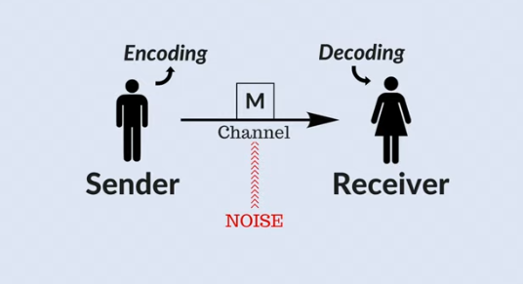

* No Feedback
* Words have all the Information

### The Transaction Model

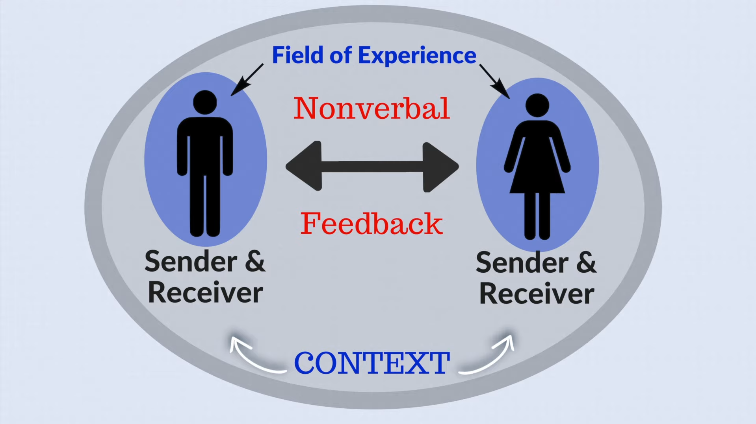

* Meaning is Among People
* Watzlawick

### The Constitutive Model

* Communication isn’t just tool for describing Reality, also shaping it.
* Example: Without constant communication (Advertising) brands would fall apart
* Without communication most things like politics wouldn’t have been established

Ein Bild, das Text, Uhr enthält.

## Speech Act Theory

* Chops interactions into smaller parts called Speech acts, which is constructed of a set of words, a verbal unit.
* Speech act is an utterance that serves a function in communication
* Examples
  + Greeting
  + Apologizing
  + Requesting
  + Complaining
* Cultural context is important
* By John Langshaw Austin
* Created to categories
  + Performative: tries to understand actions, is rather felicitous or infelicitous
    - Constitutive conditions: Necessary to successfully perform an speech act
    - Regulative conditions: Concerned how to happily or how well it is performed
  + Constative: Making a statement (can be true or false)
* Speech acts can be:
  + Locution: linguistic properties and meaning
  + Illocution: Manifest (explicit) intention
  + Perlocution: Effect on the listener
* 5 Speech Acts by John Searle
  + Assertive: Statement
  + Directive: Provoke action
  + Commissive: commits to action
  + Declaration: defines a reality (declaring something)
  + Expressive: Psychological Status of a situation

# Media Choice

How do we select Media:

* As how personal is a medium received
* How much information does a medium convey
* How does media help to get so synchronicity

## Social Presence Theory

**Definition:** Social presence is defined by the various apparent physical proximities created by different media. It is measured by the ability to project and experience physical and emotional presence from others in interactions and represents a one-dimensional property of a medium allowing to hierarchize communication media.

Rating human interaction on measures like:

* Personal – Impersonal
* Warm – cold
* Humanizing – dehumanizing
* Sensitive – insensitive

Central Statement: Convey the Social Presence necessary for as cheap as possibleEin Bild, das Text enthält.

## Media Richness Theory

Enterprises process information to reduce uncertainty (lack of information) and equivocality (ambiguity of information). Uncertainty can be reduced by providing a sufficient amount of information. More information are needed to reach common understanding. The ability that information promotes a common understanding is called information richness.

Media Richness theory evaluates media on how many expressions it can convey. Determinants are:

* Immediate feedback – no immediate feedback
* Range of communication channels and cues – single channel
  + Channels (audio / visual / etc.)
* Personalization
* Variety of languages (body language, natural language, formalisms)

Ein Bild, das Text enthält.

Effective communication chooses a medium to cover its information equivocality. A information that can be interpreted differently should be conveyed by rich media else the message could be oversimplified.

Criticism: Studies show a direct correlation of Business performance and media richness theory and it was developed in 1980, where digital media wasn’t as established.

## Media Synchronicity Theory

Puts media choice into 3 dimensions:

* Type of communication process
* Capabilities of the available media
* Appropriation factors

**Definition:** Synchronicity is a state in which individuals are working together at the same time with common focus. Media synchronicity is the extend to which the capabilities of a communication medium enable individuals to archive synchronicity

Media synchronicity theory looks how well a medium suite the communication process, how the information are trans missioned and processed.

The authors of the theory propose two tasks, Conveyance process (transmission Distribution of new information and making sense of the information in mental models) and Convergence process (Exchange of preprocessed information and agreeing on the meaning in a group)

**Media Capabilities and Synchronicity** get defined by 5 aspects:

* Transmission velocity: how fast can we transmit information
* Parallelism: how much can be transmitted simultaneously
* Symbol set: variety of formats for communication: (visual, verbal, written)
* Rehersability: Opportunity to finetune a message before transmission
* Reprocessability: Opportunity to reexamine a message after its reception

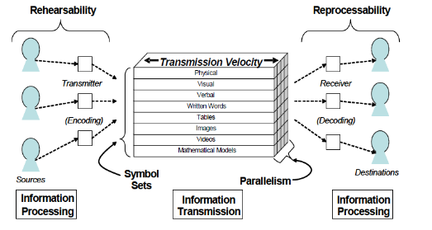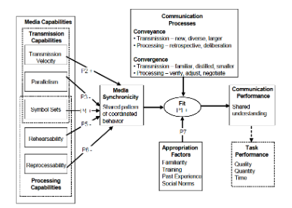

**Communication Processes and Synchronicity** states that there isn’t a “richest” medium. The synchronicity should be evaluated in the context of the communication process. **Conveyance** processes need quick information exchange and less information processing and benefit from low synchronicity, while Convergence processes benefit from slower information transmission and more processing, and thus from higher synchronicity

Ein Bild, das Tisch enthält.

# Affordance

* How the environment enables our actions
* Dividing affordance into Environmental / Functional / Technological Affordance

## Affordance Theory

**Affordance** is described as the possibilities it offers in behavior and actions. It implies the complementarity of the animal and the environment. It can be differentiated into attached and detached objects, which offer affordances.

**Environmental Affordances** animal-relative properties of the environment. Relations between the abilities of animals and features but aren’t properties of the environment or the animal, it’s the situation that enables a particular activity.

**Application to Information Technologies**, affordances enable and constrain actions. Affordances can be extended with technological artefacts which can design affordance. Humans can exploit these artefacts (e.g. camera). Affordance is helpful to analyze IT properties and explain the effects of IT.

**Functional Affordance** can be described as the relation ship between a technical object and its user.

**Technological Affordances** are potential for behaviors associated with achieving an immediate concrete outcome and arising from the relation between an object and a goal-oriented

actor or actors.

**Critical Appraisal**

* Concept is intuitively appealing
* Provides a broad lens
* Variety of understanding of the concept exists
* Little consensus

## Affordance Actualization

**Affordance existence:** Affordance exists regardless of the actors perception,

**Affordance perception:** To exploit their potential actors must first perceive affordance

**Affordance actualization:** Action taken by actors by applying one or more perceived affordances to archive outcomes

**Affordance effect:** Potential to cause an event, Immediate and concrete outcome from the actualization in the short term and contribution to long term organization goal

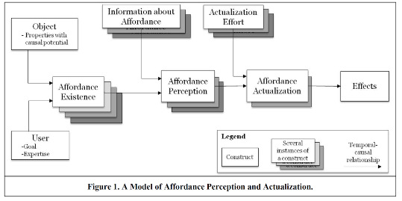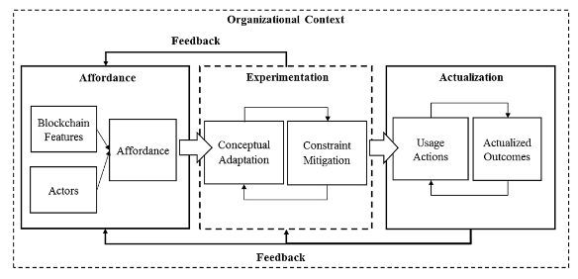

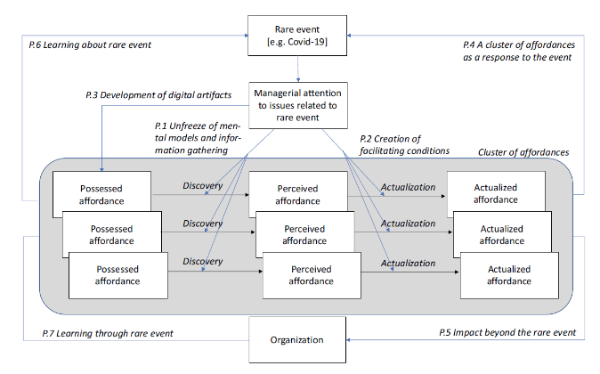

# Groupware

* How computers enable communication and collaboration
* Groupware as part of Computer Supported Cooperative Work
* Where Groupware is used
* Dividing Software into multiple categories

## Basic Terms and History

**Computer Supported Cooperative Work** looks at how people work in groups with enabling technologies and looks at computer assisted coordinated activities like communication carried out by a group of collaborating individuals.

**Groupware** is a computer-based system that supports a group of people in a common task or goal. Specialized computer aids collaborative work groups.

**First Steps** were try to use computers complementing human problem-solving.

**Experiments** emergedof CSCW in the 1980 and had big influence on design oriented research and the development of first prototypes. The first wider adopted technologies were text based communication technologies, like e-mail.

**Discovery** Email, Lotus Notes and MS Exchange / Outlook got widespread adaption. During the dot com boom there was a many more software platforms were developed, like Internet-based groupware systems to satisfy a greater organizational demand.

## Purpose and Challenges

**Purposes:**

* Computer-Mediated communication
* Collaboration systems
* Shared applications

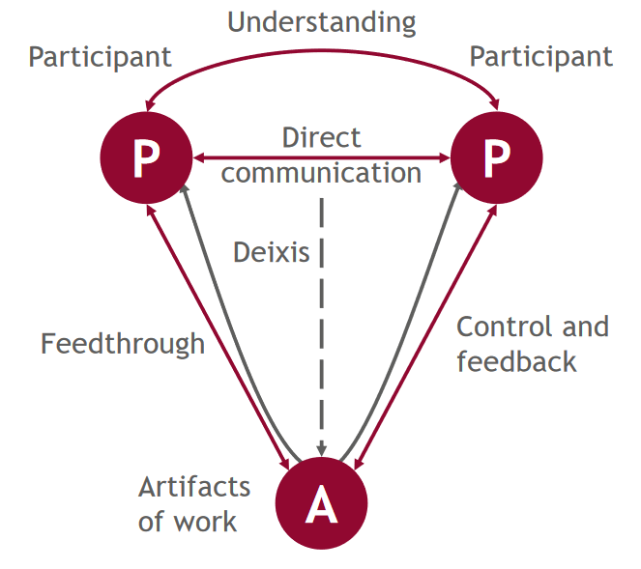

**Challenges:**

* Utterances are highly ambiguous
* More difficult when participants are not co-present
* References like they can refer to multiple things
* Network delays / time differences can facilitate missunderstandings
* Lack of implied sequentiality

Ein Bild, das Tisch enthält.

## Classification

**3-C Model:**

* Communication Support
* Coordination Support
* Cooperation Support

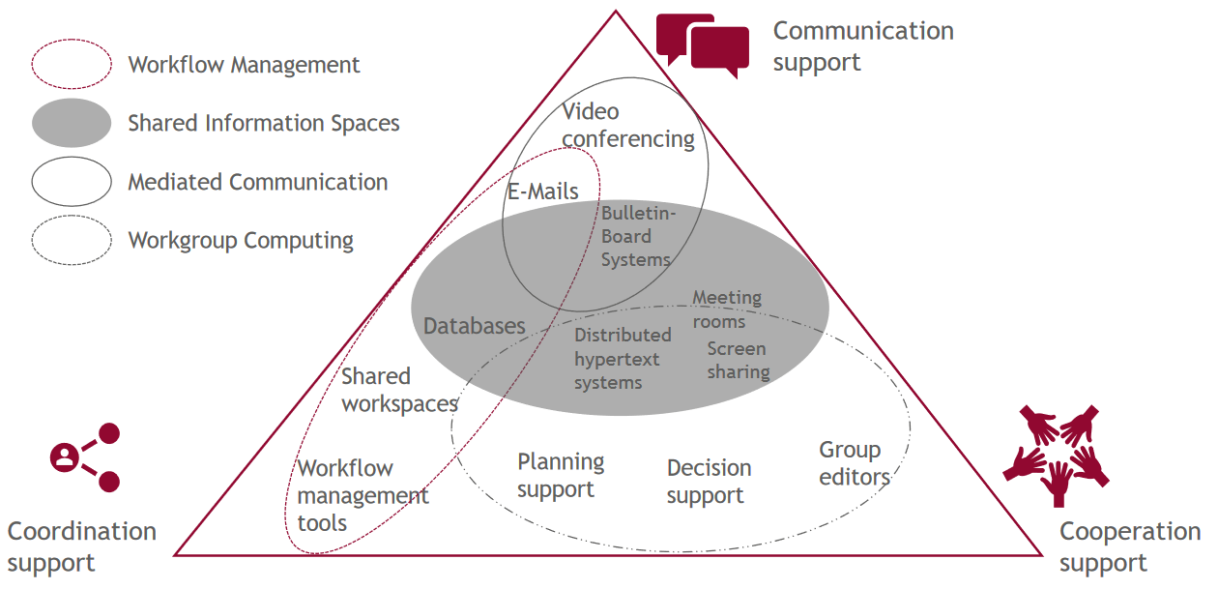

**Time-Space-Matrix**

Ein Bild, das Tisch enthält.

**Extended Time-Space-Matrix**

Ein Bild, das Tisch enthält.

**Catalogue of Classification Criteria**

Ein Bild, das Tisch enthält.

**4 System Classes: Overview**

Ein Bild, das Tisch enthält.

# Knowledge Management

* Difference between Data, Information, Knowledge and Wisdom
* What is tacit and explicit knowledge
* How knowledge is facilitated in Corporations
* Functions of knowledge management Systems

## What is Knowledge

Information is the basis to generate knowledge. Knowledge is the belief gained out of an Information. Means Knowledge is personalized. Knowledge comes out of processing information to learn off or reflect on.

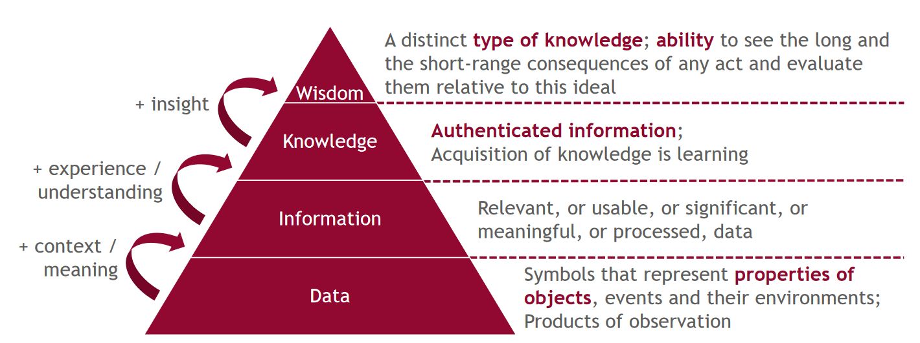

**Tacit Knowledge:** are things you can do but cannot grasp into words (like doing a Ju-Jutsu technique or playing Osu! (just click the circles man)) **Explicit Knowledge:** are things you can grasp into words and are accessible through consciousness (like how a computer functions).

**Knowledge Iceberg**

Ein Bild, das Text enthält.

**Defining Knowledge**

1. Justified true belief = Something that makes sense and fits into our world view (e.g. Magnets attract each other)
2. Actuality of skillful action = to be able to define, prepare and solve a task or problem
3. Is explicit and tacit along a continuum.

**Modes of Knowledge Creation:** Individuals accumulate knowledge (tacit as well explicit) by interacting with the world. This knowledge moves upwards in organizations from an Individual level to a group level, to the organization level. During this process knowledge is also created, shared, amplified, enlarged and justified in organizational settings through social interactions and individuals cognitive processes

**The SECI Process of Knowledge Spiral**

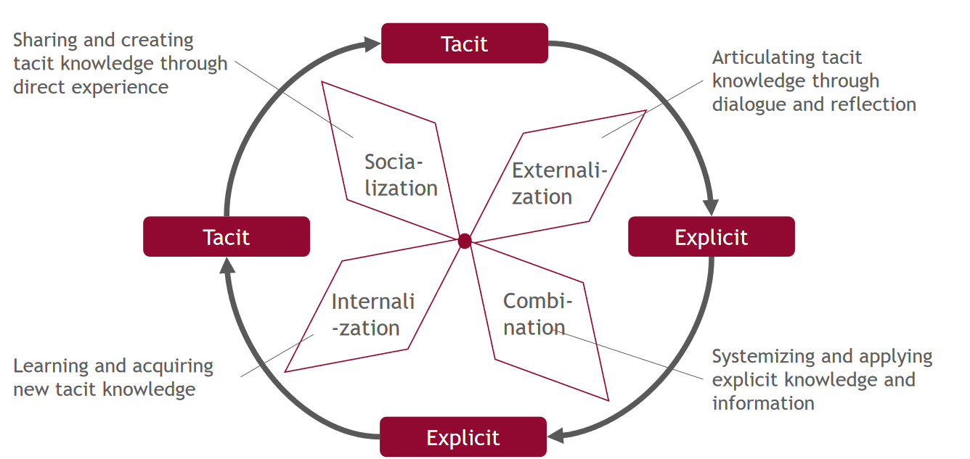

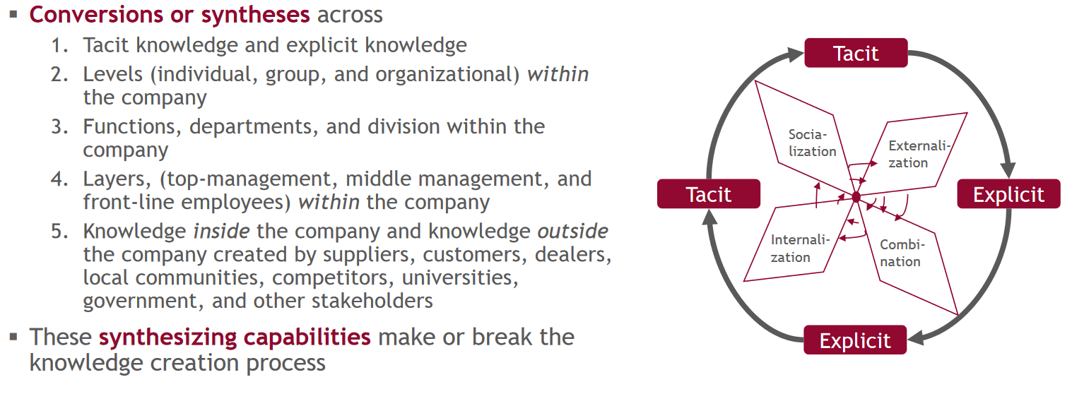

**The Value of Knowledge** is increasing because we are shifting to a more knowledge economy, with challenges of big uncertainty and complex competitive environment, which increases the value of intangible assets.

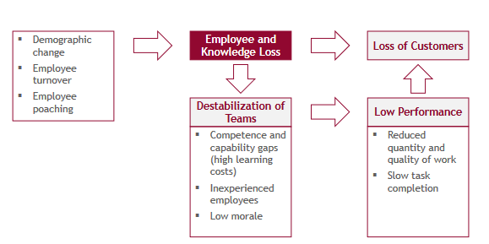

## What is Knowledge Management

Processes of identifying, capturing, and leveraging knowledge by Sharing and transferring it inside the company to help it compete. This includes how knowledge is created, stored, retrieved, and transferred and applied. It’s a dynamic part of the company.

Knowledge Management focuses on three pillars:

* People and culture: People are the source of knowledge and culture how effective knowledge is shared
* Processes describe how knowledge is developed, captured, shared, and applied inside the organization
* Technology should support the processes involved

**People and Culture:** Knowledge Management needs top-down support, to overcome the unwillingness to share knowledge of other people and to define what information and knowledge is worth capturing. Because people play a huge role it’s also worth identifying the needs and wants and should be supported in communication, change and performance management.

**Knowledge Management Processes**

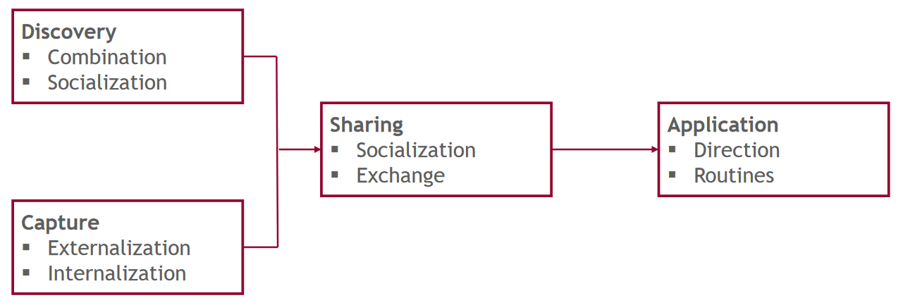

**Discovery:** developing new tacit or explicit knowledge from data and information or synthesis of prior knowledge. Combination of multiple explicit knowledge streams to create new knowledge or having existing information and trying to put it into a new structure. Socialization, using joint activities to synthesize tacit knowledge. Example: Mentoring.

**Capture:** Process of retrieving knowledge from people, artifacts or organization entities. It’s useful to use tacit knowledge from people as well as explicit knowledge from manuals. These should be externalized to words, concepts, visuals etc. to be later externalizable by learning.

**Sharing:** communicating knowledge and allowing the people learning to incorporate it into their action. To facilitate knowledge inside your business you want socialization and exchange inside of your business.

**Application:** the incorporation of knowledge helps the company to make decisions but is dependent on the knowledge inside the corporation. These lead to:

* Directions: directed actions without knowledge transfer
* Routines: Procedures rules and norms that guide future behaviour, but these take time to develop

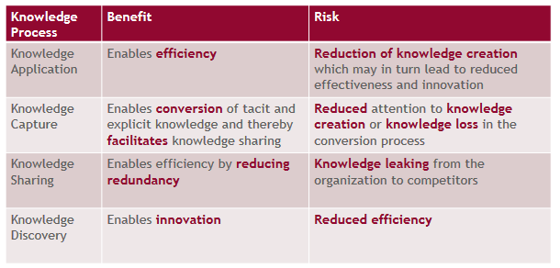



## What are Knowledge Management Systems

**Definition:** IT-based systems developed to support and enhance the organizational process of knowledge creation, storage / retrieval, transfer and application.

Knowledge management systems are large scale collaborative systems with the focus on managing knowledge and knowledge resources

**Why Use KMS:** Organizations can quickly establish decisions based on existing and novel knowledge. Used as a data storage medium, that also allows distribution of knowledge. Also helps at the creation of knowledge by usage/implementation of a KMS

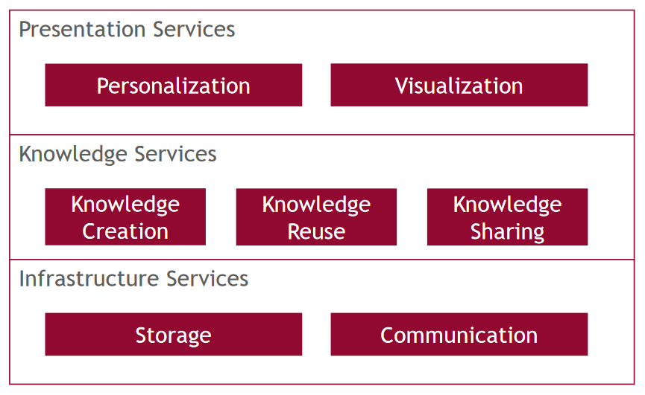

**Enterprise Search Platforms:** how can employees quickly find answers, when information is hidden and scattered in different sources. These ESP are a single application that gives full access to all enterprise contents, via search through multiple structured sources, like databases as well unstructured sources, like emails, to grand immediate access to relevant information.

# Individual vs Collaborative Work

## Working Modes and Spheres

**Individual Work:** Work that is done in different episodes of collaborative work and in-between. It’s used to synthesize information. The Individuals need time to understand tasks and build mental models, (so called conveyance). These Tasks get done individually because they benefit from being done in a focused and concentrated manner, without interactions and interruptions.

**Individual Work as Part of Collaboration:** after the deep work is done, the team meets again to archive shared understanding. These switching between independent work and work with high interdependences is called the rhythm of collaboration.

Ein Bild, das Text enthält.
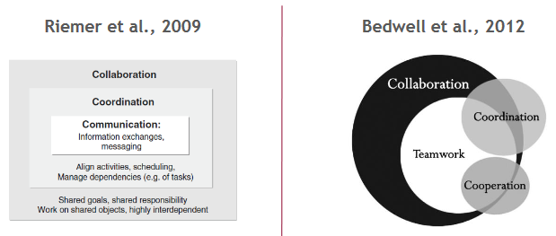

**Collaborative work and individual work:** Synchronous collaborative work are Mediated, in-person or everything in-between, like workshops dialogues and meeting. Asynchronous collaborative work is when people work on their own but get interrupted or to interrupt others. Individual work is the absence of collaborators but can be divided into deep work or shallow work.

**Deep work:** is performed in a state of heavy concentration that pushes cognitive abilities and requires setup and a lot of brain power. Things like deep work are coding…

Ein Bild, das Text, Handkarren, Säge, Werkzeug enthält.

**Shallow work:** This work isn’t cognitive demanding and can be done while distracted. Scheduling a meeting

Ein Bild, das Text enthält.
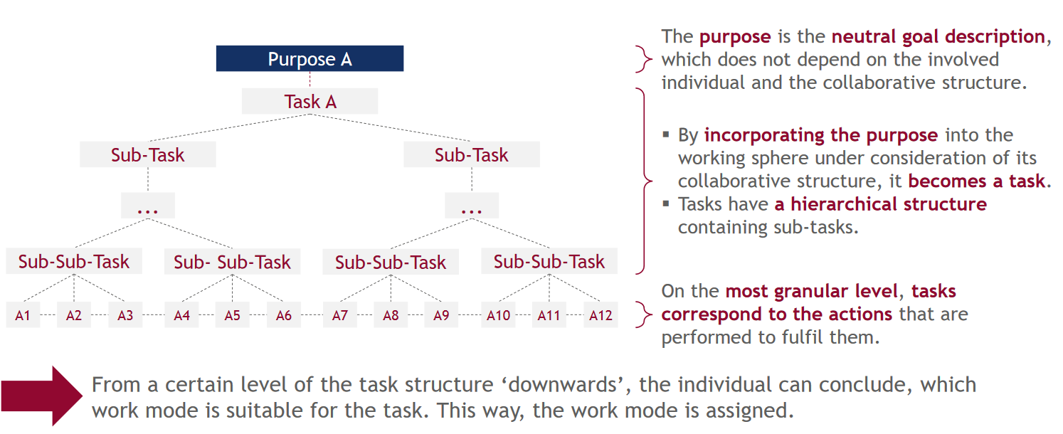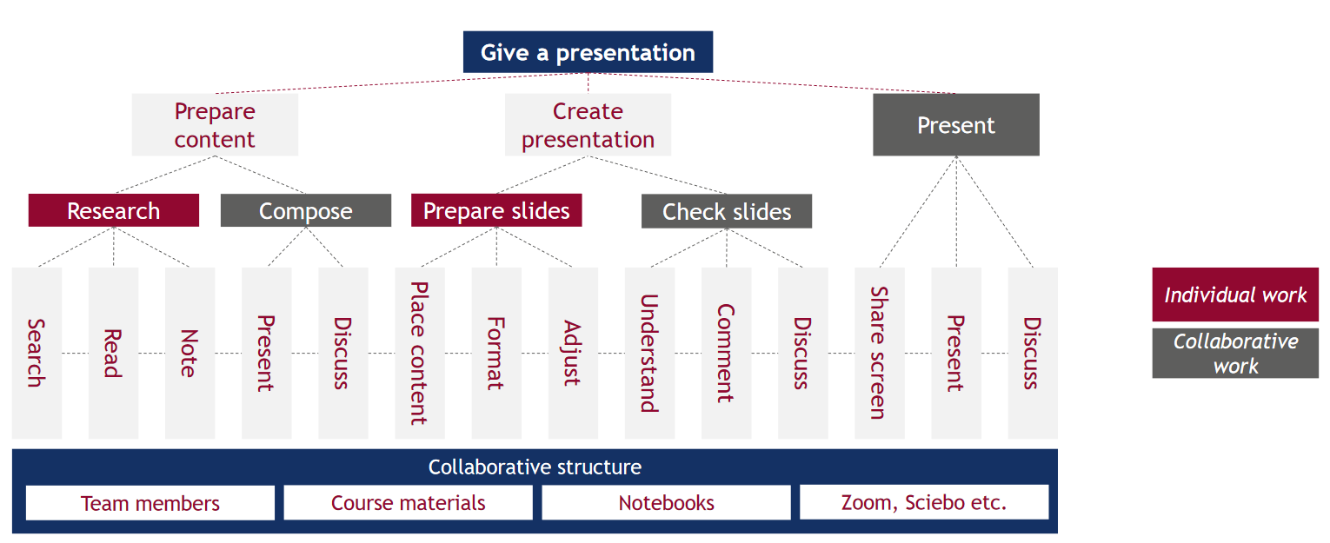

## Work Types

|  |  |  |  |
| --- | --- | --- | --- |
| **Name** | **Maturation Work** | **Execution Work** | **Meta Work** |
| **Work Content** | how can the task be divided, how can the individual outputs be combined again | how can we create value | Management of resources (including themselves), Micro (done daily or weekly) or macro (monthly or yearly) |
| **Outcome** | Translate the purpose into a task. Sub tasks should be independent and as executable as possible | Might serve as a resource, working sphere expires, further maturation work | Organizing work and prioritizing tasks |
| **Organizational characteristics** | Unstructured, non-linear, and improvisational. Explore the collaborative structure (how’s good at what), high amount of collaborative work, with individual (shallow) work | high amount of deep individual work | Can consume lot of attention at times, (Self-imposed) interruptions due to async nature, need to align the own working spheres organization to those of coworkers |

**Interplay**

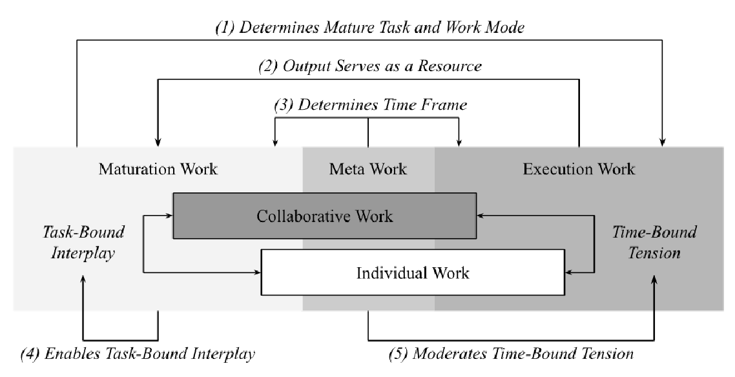 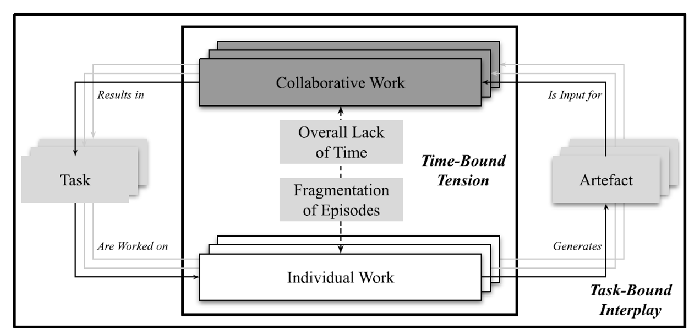

**Planning Philosophies**

* Journalistic Philosophy: Individual work in-between collaborative work (when you got the time). Individual work as a residual value.
* Bimodal or Rhythmic Philosophy: Lot of Metawork, to schedule individual work with the demands of collaborative work. Bimodal, switching between deep and shallow work as it is needed for the groupwork, while Rhythmic Philosophy tries to alter between shallow and deep work on a daily basis

**Example**

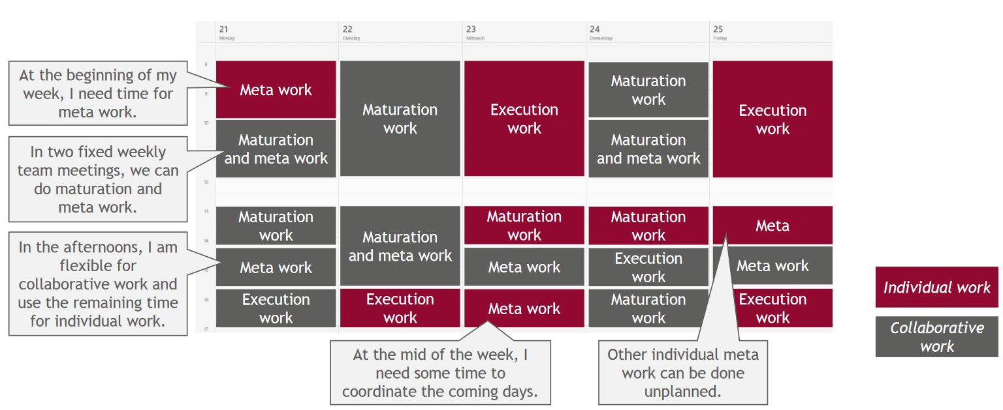

## Projectification and Overload

People relate to projects to project organization in their working lives. They even speak and think of their daily activities in project terms.

**Traditional Organization:**

* Flow Process orientation
* Thought of as permanent
* Stationary location of activities
* Regulate employment relations
* Managerial control

**Project Based:**

* Temporary system and structure
* Constant transformation and flexibility
* Facilitated by modern ICT
* Flexible employment conditions
* Individual responsibility and empowerment

**Projectification in Germany:** transformation from a functional organizational structure to autonomous project teams. More than a third of the value creation in Germany took place in projects. Project work gets more important.

**Multiple Projects:** Projects are used to solve a unique and complex problems using experts from various disciplines. Routines are repetitive tasks. With the trend that organizations are using more projects to adjust to changes, workers who are deployed in to many projects could suffer from stress or even burnout

**Project Overload** is the fragmentation, disruption and inefficiency caused by switching between commitments to simultaneous projects perceived among project members

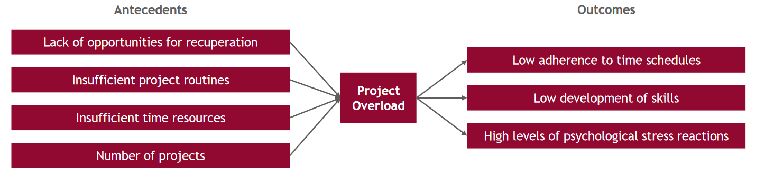

**Related Overload Constructs**

* Information overload – requirements exceed information-processing capacity
* Communication overload – lack of quality and excess of quantity, feeling overwhelmed
* Email overload – stress and interruptions
* Technology overload – use of technologies yielding diminishing returns

**Collaborative Overload** describes a growing share of communication and collaboration activities, leading to structurally too much time and energy spend in collaborative work, ignoring the individual balance of collaborative and individual work.

# Agile Working Modes

## Agility

First software development was done like traditional handcrafts, in a so called “code and fix” manner, which resulted in spaghetti code. To improve the process of software development, software engineering and engineering principles were introduced, and resulted in so called plan-based methods.

**Plan-based Methods** are methods that require requirement analysis and solution planning, to apply standardized, mainly sequential process steps with extensive documentation. These steps consist of analysis, planning, programming, implementation, and testing.

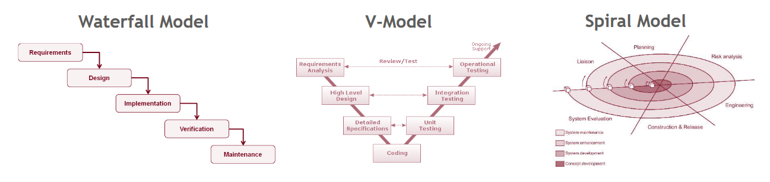

These methods still come with disadvantages:

* Large overhead
* Tests and customer involvement are too late
* Not a lot of learning from mistakes
* Doesn’t adjust quickly to dynamic markets
* Customer requirements are hard to get into the planning phase due to sequential process
* Changing things is costly

## Scrum & Kanban

Scrum is an Agile work approach to develop software in a human centered collaborative approach. That works in Iterative and incremental steps. It focuses on delivering business value and a close cooperation with the customer.

**Scrum Roles**

* **Product Owner**, is responsible for the project to the sponsors, defines requirements, objectives and release plans. He also decides when what parts of the product will be shipped
* **Development Team,** is responsible for creating the finished product including the requirements. They are self managing, organizing and cross functional. They are doing their work iterative and incrementally. In so called sprints.
* **Scrum Master,** is responsible for implementing scrum into the organization culture and teaching and supporting in scrum related issues. He has respect due to his experience.

**Scrum Flow**

Vision -> Plan -> definition of (non) functional requirements -> Prioritization of requirements and release date.

Execution of sprints that are around 30 days long. Sprint meeting at the start to propose the highest priority of the product backlog, to be worked on, and questions from the team to clarify requirements. After the meeting the team Plans the sprint and creates a sprint backlog.

Every Day starts with a meeting where the team members say what they’ve done, what are hurdles. This is to synchronize the work of the team.

At the end of a sprint there is a sprint review meeting where the team, product owner and stakeholders determine what’s to do next. Also the team does a sprint retrospective meeting to revise its development process

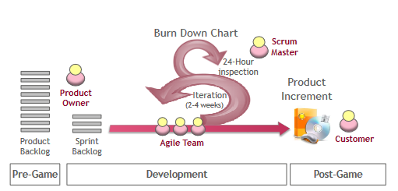

## Communication in Agile Working Modes

**Team Distribution:** Co-located team have an easier time to communicate than distributed teams. Agile tries to help communication hurdles by forcing teams to communicate. Informal teams can use informal communication, while large teams need formal communication to coordinate. Mission critical systems should be communicated, face to face and formal as well the information needed to maintain the project and retain knowledge.

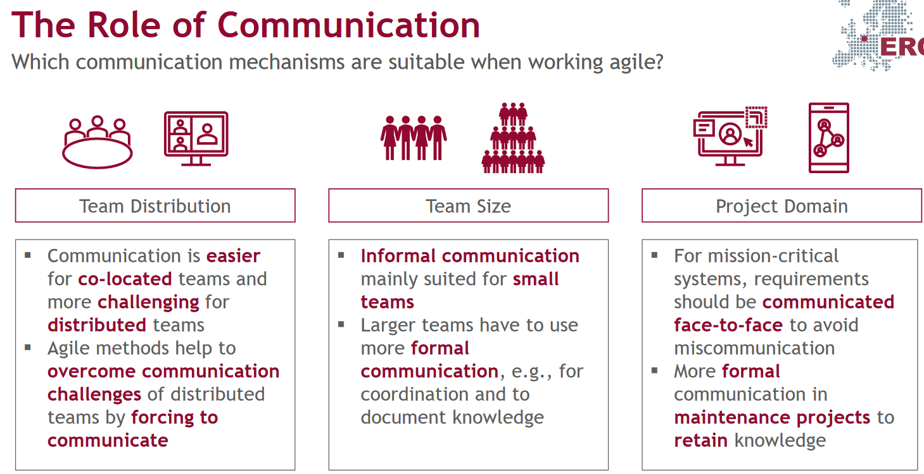

**Social Agile Practices:**

* **Co-located office space:** quick and effective communication. Customer representative can issue immediate direct feedback and answers. Allows face to face communication
* **Daily stand-up meetings:** enables high frequency and high amount of direct communication. Keeps people up-to-date. Allows to identify and solve problems.
* **Iteration planning meeting:** enables direct, frequent communication with the customer representative to discuss the implementation of new features.
* **Pair programming:** enables frequent, direct communication, when what code is written. know-how and training during these meetings for new employees.
* **Sprint retrospective:** enables frequent, direct communication to revisit the lessons learned. Improves communication, it allows to reflect on the communication behavior on the team.
* **Sprint review:** enables frequent, direct communication with the customer to discuss iteration results. Allows addressing major issues that hinder the project.

**Documents:**

* **Documentation of important decisions:** agreements with stakeholders or decisions
* **Product backlog:**
* Retrospective agreements
* Source code documentation
* Test documentation
* Time, budget, and task coordination
* Training material

# Building and Leading Virtual Teams

## Virtual Teams & Group Formation

**Team:** People / Stakeholders working together to archive a common goal

**Virtuality:** difference in time and location between team members

**ICT (Information and communication technologies)** are used to overcome physical and temporal distances

**Stages of building an effective team**

|  |  |  |
| --- | --- | --- |
| Stage | Characteristics | Tasks of Group Members |
| Forming | Insecure about group safety, belonging, rules and procedures | Ensure to be accepted Determine whether to accept the others |
| Storming | Attempt to balance influence and responsibility by individual members | Define values and goals  Gain influence over workload  Obtain responsibility over outcome |
| Norming | Mature negotiations about goals; design of structures inside the group; how to archive objectives | Divide roles and responsibility  Establish trustful relationships with other members |
| Performing | Productivity and effectiveness |  |

**Virtual Challenges:**

* Group members cannot identify referent others that are similar in ability
* Conforming to perceived group norms cause of lack of individual identity
* Likelihood Socially unacceptable behavior increases

**Group Development of Virtual Teams:**

* Sense of Belonging
* Goal commitment
* Trust in peers
* Team performance
* Decision Scheme Satisfaction

**Conditions for Effective Virtual Teams**

* **Common Ground:** knowledge participants have in common, higher common ground means better performance in virtual teams
* **Working Coupling:**
  + **Tight:** Work is dependent on talent, and non routine and/or ambiguous
  + **Loose:** few interdependent components
  + Loosely coupled work is better for virtual teams than tightly coupled work

**Advantages:** Groups can be formed quicky and be dissolved quickly and people quickly find a sense of belonging due to increased conformity.

**Disadvantages:** Due to heavy conformity groups might not pass past the forming stage and its hard to form relationships

**Recommendations:** One Step at a time, resolve issues of the first stage before moving on and do not restrict communication and be on the same page to complete tasks.

## Leadership in Virtual Teams

**What makes a leader:** contract between leader and followers, that gives leader social control. He influences group perceptions, behavior and performance. He gets elected by the quality to handle situations.

Leaders should have following attributes:

* Integrity
* Authenticity
* Visionary
* Empathy

**Types of Leaders**

* **Appointed Leader:** Is someone appointed to be a leader by higher ups. He Adopts behaviors that are associated with leadership positions: Organization/ guidance, gives orders and has self-constraint
* **Emergent Leader:** Member that is perceived to be in command by the other members cause of quantity of interactions, cognitive abilities, and factor on team moral

**Virtual Effects on Leadership**

This section focuses on computer-mediated-communication (CMC) and how it affects a leaders position

* Option 1: too impersonal -> weakens leaders position
* Option 2: increases precepted characteristics -> strengthens leaders position over time
* Option 3: reinforces roles if group members share a common social identity -> depends on group consensus

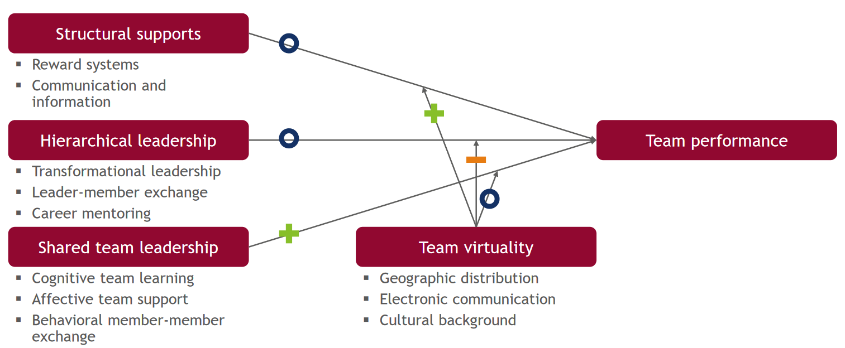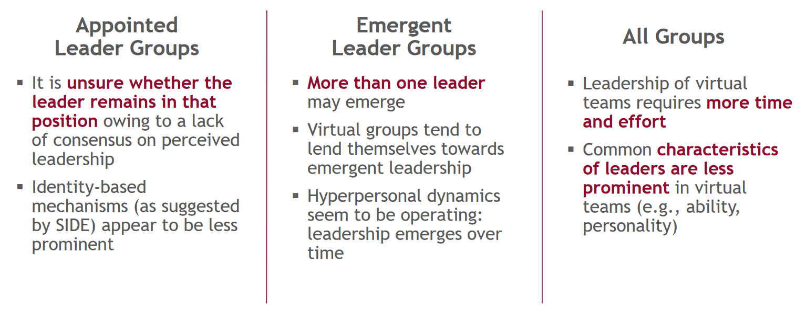

**Leadership Dimensions in Virtual IT Teams**

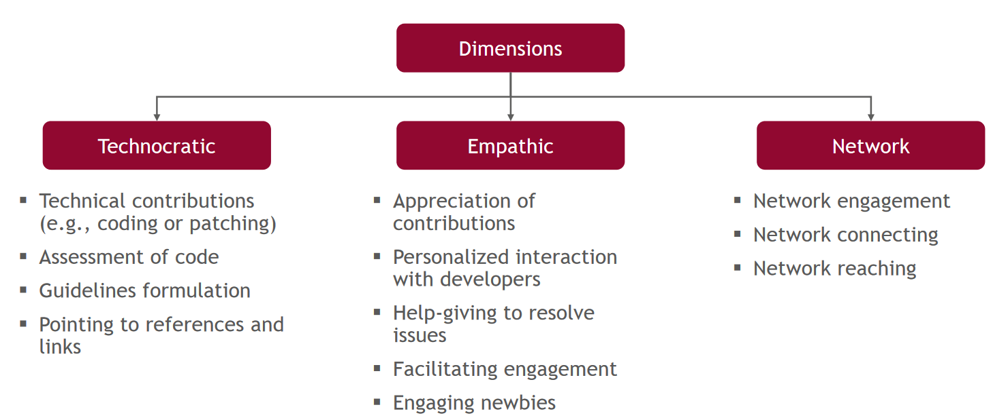

# People Analytics

## Data-Driven Leadership and People Analytics

**Influence of Employees Data on Leadership:**

* **Decision-Making:**
  + The nature of the problem
  + The degree of structure of the problem
* **Information Processing:**
  + Communicate at different levels
  + Big data analytics
* **Interpersonal**
  + People-oriented

Ein Bild, das Tisch enthält.

**Information System:** Role to collect, process, store, analyze and disseminate information to support leadership

**Leadership-Related Information System:** Support operative and strategic goals and manage employees on an interpersonal level and exercise authority to co-ordinate tasks

**People Analytics:** data-rich insight into organizational resources, processes and people and their performance, to make better decisions an manage people more rational.

**Definition of People Analytics:** Computational applications that leverage digital data from multiple organizational areas to reflect different facets of members behavior. Utilizing algorithmic technologies, PA analyze these data for patterns and present decision makers with more granular views of organizational resources, processes, people and their performance.

* **Modern HR Function:** Data-driven decisions over intuition to inform traditional HR processes.
* **Transform General Business:** Involves all kind of business operation that involve people
* **Data and Technology Driven:** Big data, computational algorithms, and information technology

**Intentions and opportunities:**

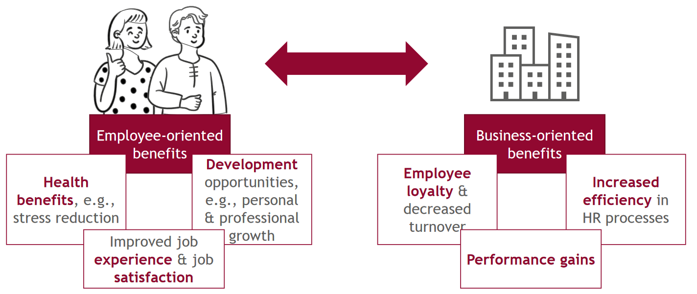

**Major Fields of Application:**

Ein Bild, das Tisch enthält.

**People Analytics Tool:**

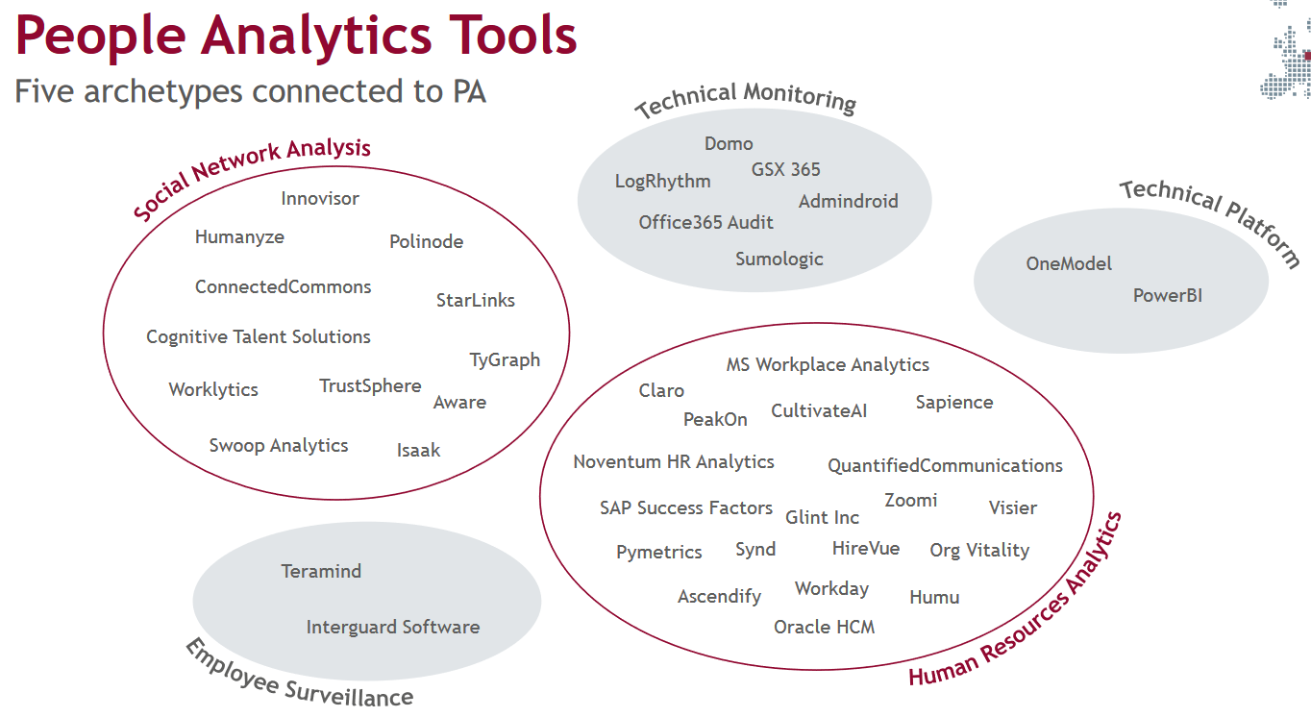

**Maturity Levels of People Analytics:**

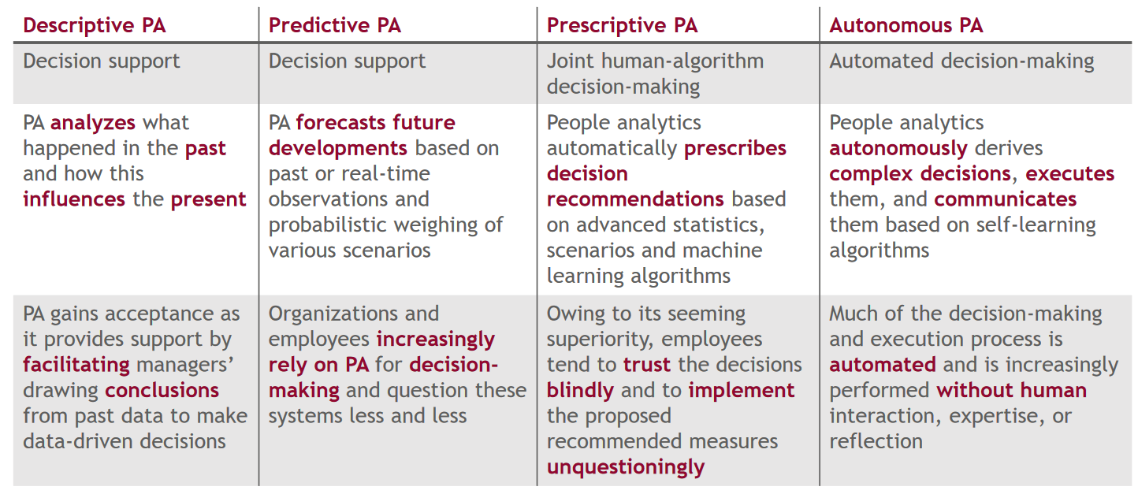

**Central Assumptions:**

* Managerial decision-making should be a rational, objective and go for the best option like in a computation model
* Big Data allows to make better and more accurate decisions
* Using algorithms makes decisions more efficient and consistent

## Privacy Issues in People Analytics

**Privacy in General:** Privacy can be divided into physical privacy and informational privacy. Privacy describes the right to control data and to influence its determination. Privacy is dependent on the user’s perception. Due to huge data collection currently privacy concerns emerge.

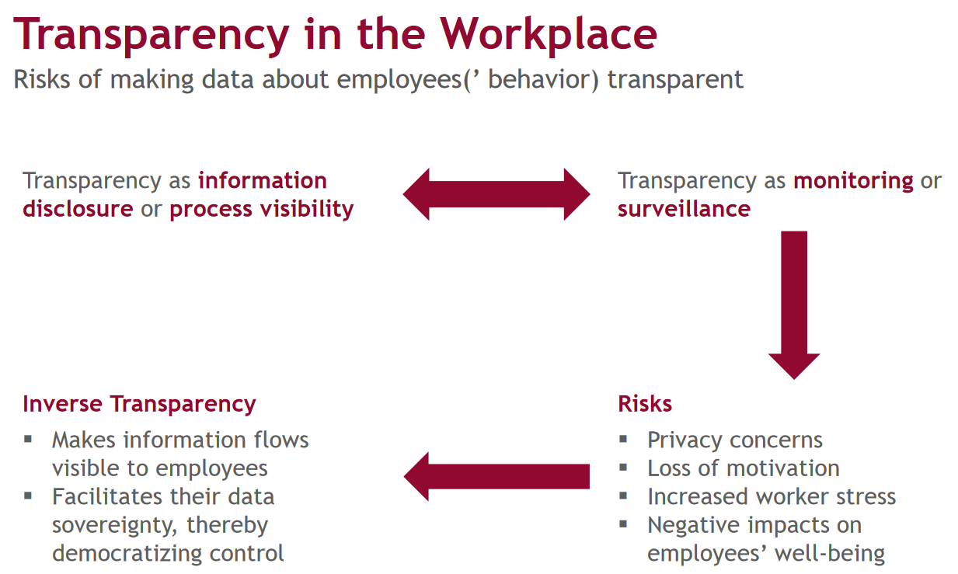

**Connection between Privacy and Transparency:** employees evaluate their privacy based on their demographics, characteristics and attitude/trust. By using digital solutions direct transparency of an employee is imposed which leads to an exchange with a stakeholders. Inverse transparency measures aim to reduce privacy concerns, e.g. privacy by design or privacy dashboards.

Environmental aspects impose direct transparency

Inverse transparency can help ease privacy concerns

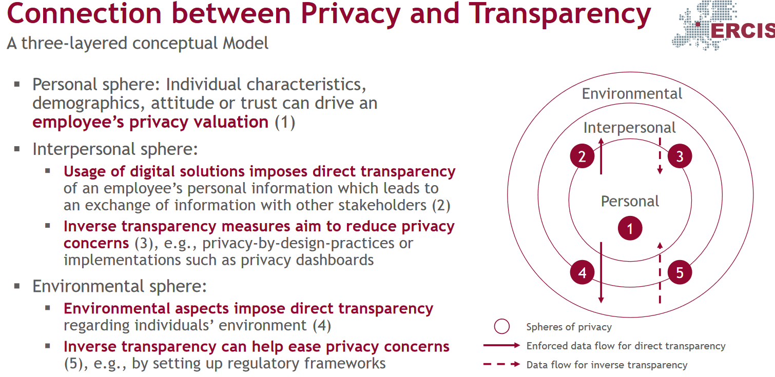

## Ethical Issues in People Analytics

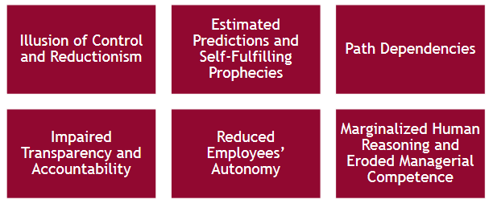

**Illusion of control and reductionism**

* PA seen as accurate and objective creates a false sense of certainty
* Model of humans is to simple to grasp all points of value
* Efficiency and fairness in decisions is only based on quantitative data

Blindly focusing on these metrics provided by PA creates a oversimplified framework of employee decision making

**Estimated predictions and self-fulfilling prophecies**

* Estimate predictions: conditional probabilities do not represent a occurrence of the event and not the event itself. Means if you watch the weather forecast: They say there is a 70% probability of raining, and you act like It’s going to rain instead there is only a chance of raining.
* Self-fulfilling prophecies: Predictions creating conditions that realize the prediction. Example: Saying you wont be able to complete an exam, thus to save time you don’t study for the exam and fail the exam.

**Path dependencies:** Predictions based on historical data represent only an extrapolation of the past. This leads to:

* Less innovation
* Backwards looking
* Inequality / social isolation

**Impaired transparency and accountability**

**Reduced employees autonomy**

**Marginalized Human Reasoning and Eroded Managerial Competence**

**Ethical Challenges Arising from the Use of PA**

* Opacity: data of some algorithms are inscrutable and untraceable
* Datafication: People might be seen as collection of objective digital data
* Nudging: Manipulative and ethically

**Vicious Cycle of Ethical Challenges**

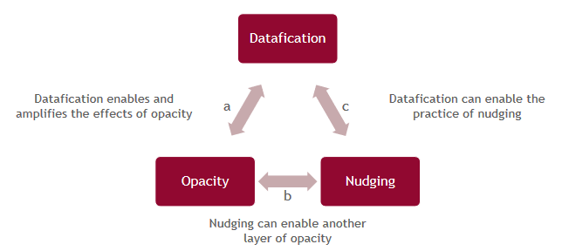

**Breaking the Vicious Cycle:** Reframe, accurately. Reflect on principles values of virtue ethics.

* Reframe PA as a fallible companion technology rather than superior epistemological (all knowing (sort of)) agent
* New organizational roles and practices. Using algorithms as well as qualitative data
* Design ethical algorithmic technologies focusing on accountability and responsibility

# Online Communities

## Basic Terms & Understanding

**Online Communities** are places where people collaborate, virtually, connected via ICT and share common interests. It consists of people interacting socially, rules and guidelines of the interaction and computer systems facilitating the sense of togetherness

**Types:** Discussion Forums which are dedicated to a certain topic. Communities of practice for learning or for professionals. Enterprise communities. Social network sites, Wikis, Creative communities and software development and Q&A sites

**Delineation of Online Communities:** because they are dedicated to a purpose or topic, they need boundaries but also members can reshape and repurpose them. Online communities are in competition with other communities over their members and retaining their own.

**Issues in Online Communities:** They need a certain amount of members (critical mass). They can develop Group Think and biases because there is a tension between diversity and assimilation. Some online communities are developed for unethical activities, like trolling, hacking or illegal trade.

## Drivers of Participation

**Types of Participants**

* **Lurker** are passive members that do not post actively
* **Poster** are active members that post regularly

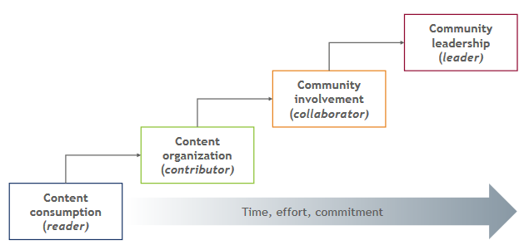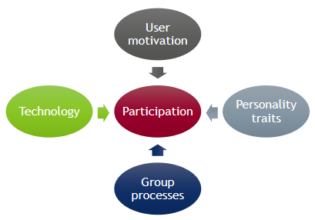

**User Motivation:**

* **Other oriented:** learn or help others, altruism
* **Self oriented:** benefit themselves
  + **Intrinsic:** rewards gained from the act like, Enjoyment, Commitment,
  + **Extrinsic:** external rewards like, Reputation building, Self-development, Networking

**Fostering Member Motivation**

* Personalized Introduction Message
* Allow Anonymity (Pseudonyms)
* Immaterial incentives, like karma reputation ect.
* Positive rewarding, non-punishing moderation style

**Personality Traits**

* **Extroverts:** spend less time online, voicing their opinion and do more social networking
* **Introverts:** prefer anonymity and asynchronicity
* **Neuroticism:** Less likely to participate, more effected by design cues

**Group Processes**

* Perception of reciprocity and similarity
* From peripheral participation to central participation
* From seeker of information to giver of information

**Technology**

* Poor interface may reduce participation
* Redesign of sites may reduce participation
* Loss of participation if technology limits limit the access to interesting content / people

## Community Governance

### Organizations

**Hosted Online Communities**

* Organization operates the platform
* Centralized definition and monitoring of communities purpose

**Autonomous Online Communities**

* Decentralized communities
* User decides community purpose and control mechanisms

### Governance Practices

**Scoping community boundaries**

* Structuring: drawing boundaries with something like subcommunities
* Fostering identification, make people who are fitting into the community feel welcome

**Nudging social relations**

* Promoting off-purpose spaces, off-topic channel in discord
* Showcasing participation, show what is happening inside the community

**Steering users**

* Moderation
* Sanction users, remind them rules exist
* Interrupt interactions
* Ban by repeated violations

**Patterns**

* Accessibility: How much the organization can change the activities and direction of the community
* Boundary multiplicity: degree to which a community is structured = subdivided boundaries

